LAB ASSIGNMENT 3.5

ǪUESTION -1: Zero-Shot Prompting (Leap Year Check)
Write a zero-shot prompt to generate a Python function that checks whether a given year is a leap year.
PROMPT:
Write a Python function to check if a year is a leap year CODE:
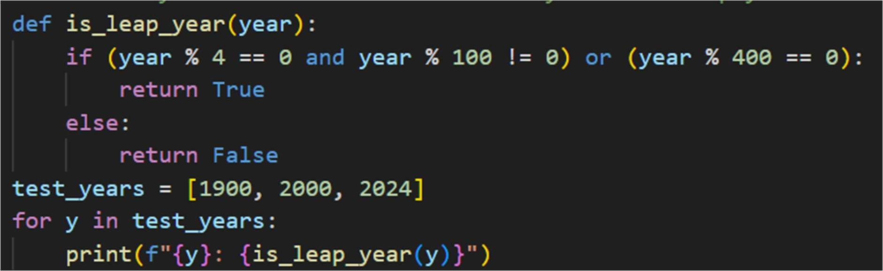
OUTPUT:

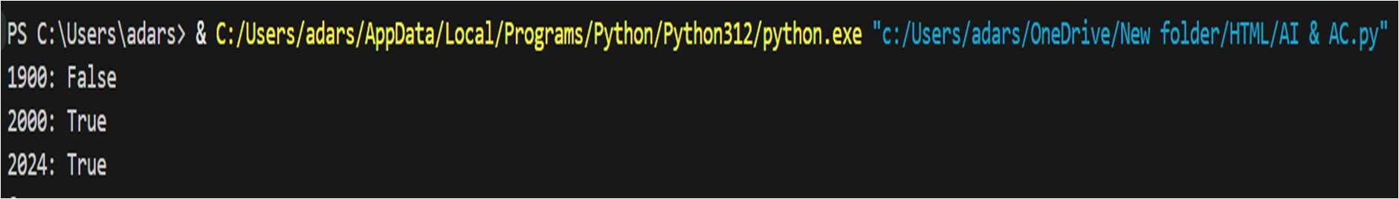
ǪUESTION 2: One-Shot Prompting (GCD of Two Numbers)
Write a one-shot prompt with one example to generate a Python function that finds the Greatest Common Divisor (GCD) of two numbers.
PROMPT: Write a Python function to calculate the greatest common divisor (GCD) of two numbers

CODE:

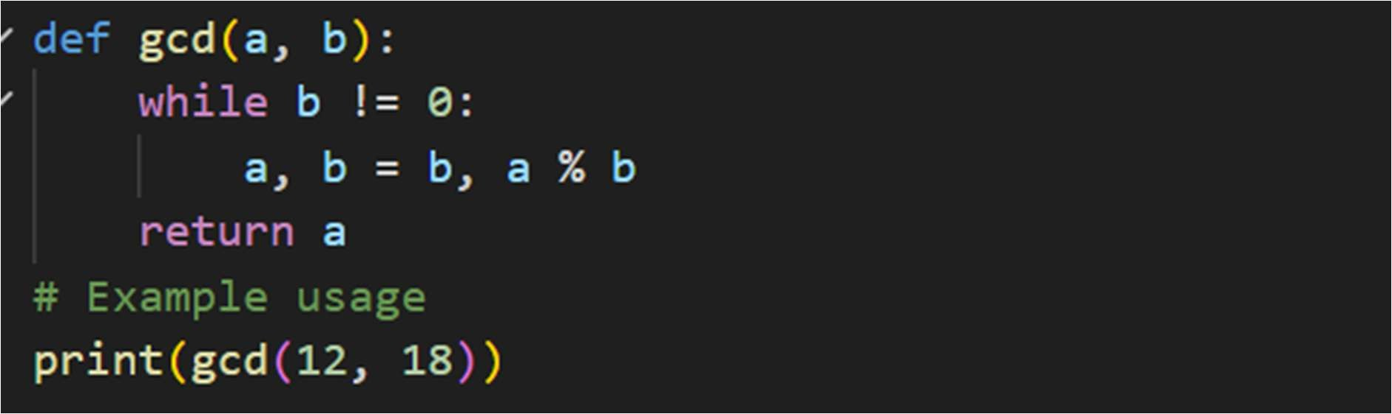
OUTPUT:
ǪUESTION 3 :
Few-Shot Prompting (LCM Calculation)
Write a few-shot prompt with multiple examples to generate a Python function that computes the Least Common Multiple (LCM)
PROMPT:
# Write a Python function to calculate the least common multiple (LCM) of two numbers CODE:
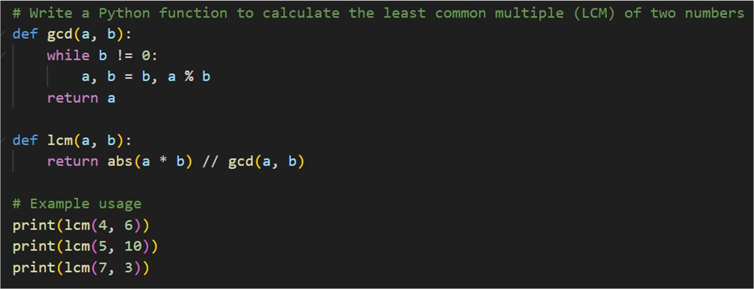
OUTPUT:
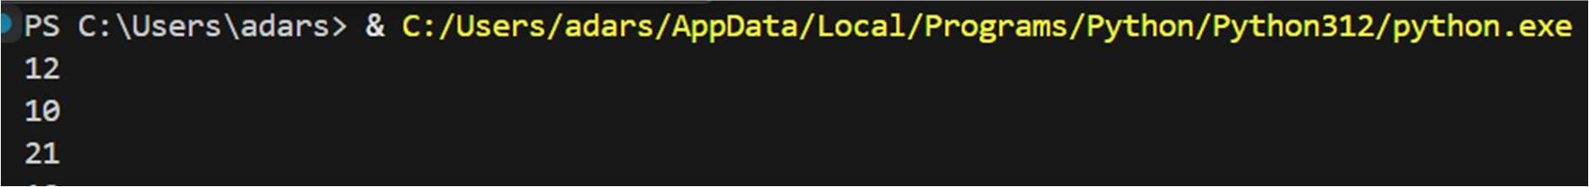

ǪUESTION 4:
Zero-Shot Prompting (Binary to Decimal Conversion)
Write a zero-shot prompt to generate a Python function that converts a binary number to decimal.
PROMPT:
Write a Python function that converts a binary number (string input) into its decimal equivalent.
CODE:
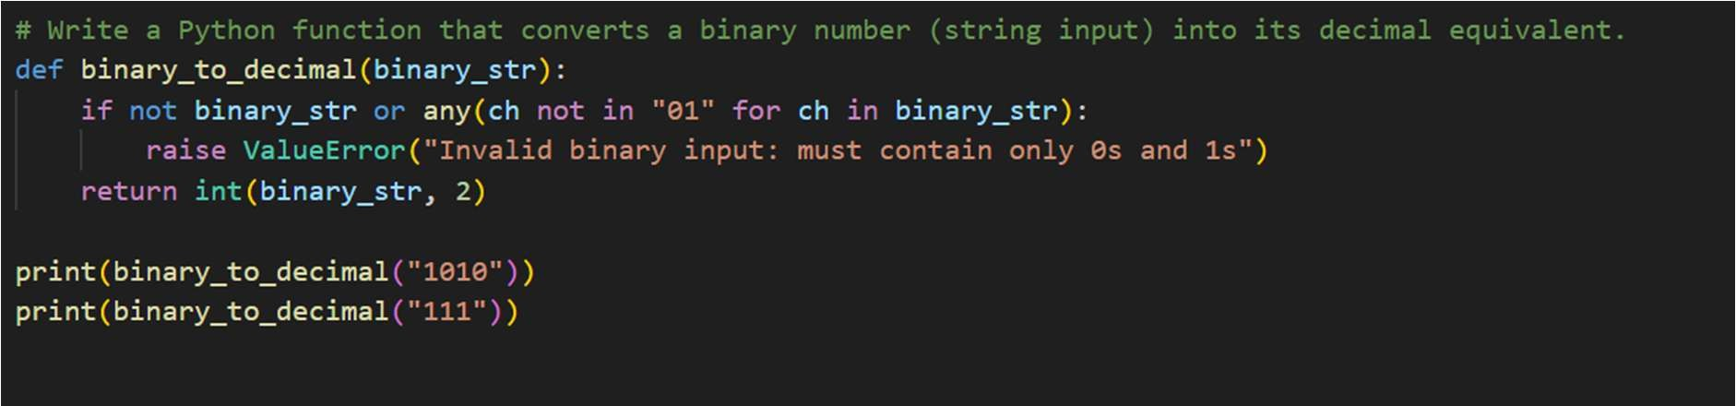
OUTPUT:

ǪUESTION 5:
One-Shot Prompting (Decimal to Binary Conversion)
Write a one-shot prompt with an example to generate a Python function that converts a decimal number to binary.
PROMPT:
Write a function that converts a decimal integer into its binary representation as a string.
CODE:

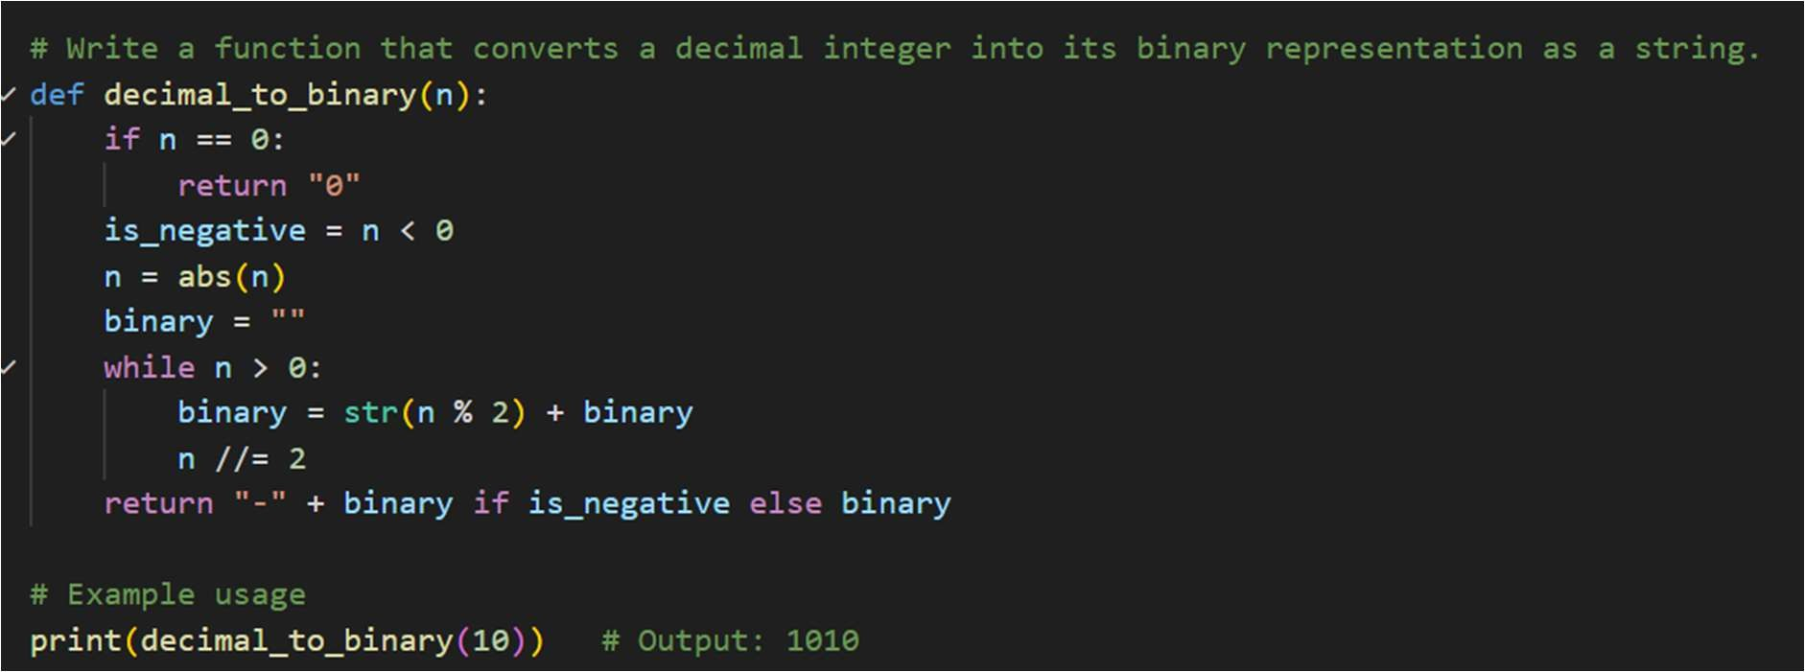
OUTPUT:
ǪUESTION 6:
Few-Shot Prompting (Harshad Number Check)
Write a few-shot prompt to generate a Python function that checks whether a number is a Harshad (Niven) number
PROMPT:
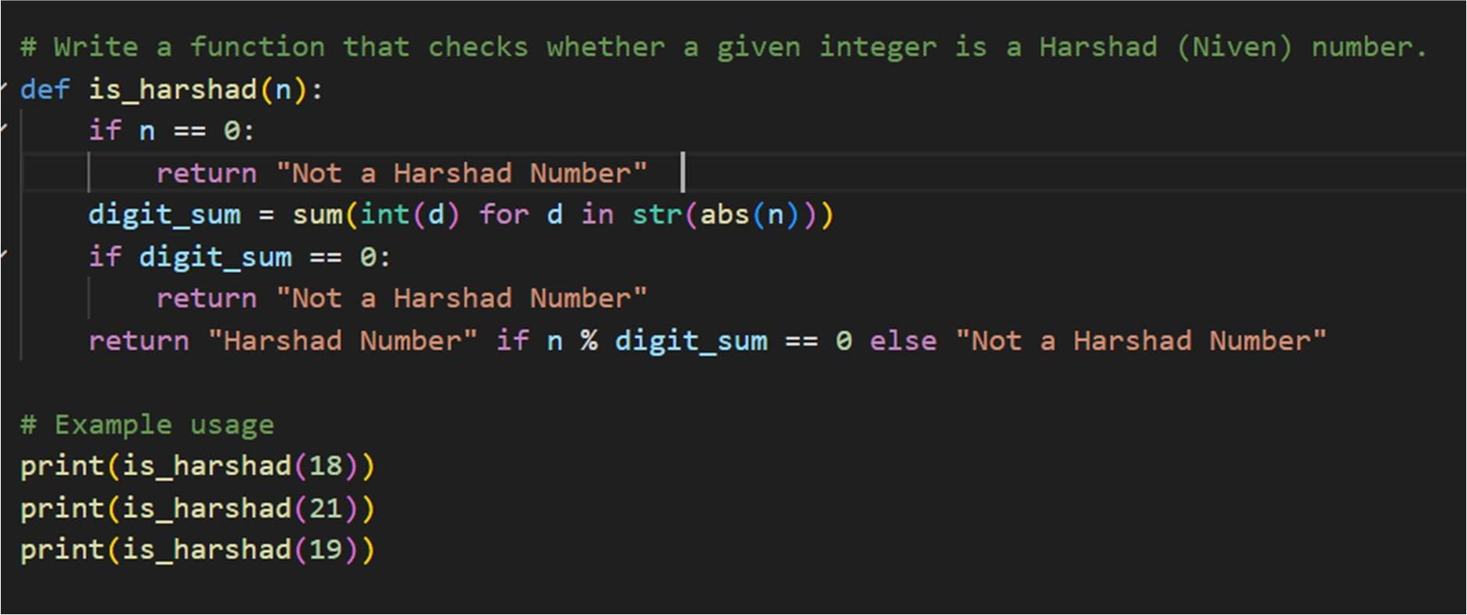
# Write a function that checks whether a given integer is a Harshad (Niven) number. CODE:

OUTPUT:

